Clarion Hotel Prague City
Tylovo náměstí 15/3, 120 00 Praha 2
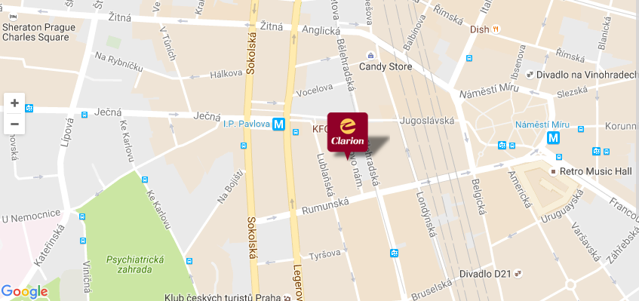
Hotel Clarion is located in the vibrant center of Prague, only 600 m from Wenceslas Square.
You can easily get to the HiLASE Center using public transport. The nearest Metro station "I. P. Pavlova" is located 200 meters from the hotel. At I. P. Pavlova take a metro and go to the station “Kačerov”. At Kačerov metro station there are the buses number 331 and 333 which are going to the village Dolní Břežany. In Dolní Břežany you get off at station “Obecní úřad”.
Please find more details about timetable at this website: http://jizdnirady.idnes.cz/praha/spojeni/


