Hotel ILF Prague City
Budějovická 15/743, Praha 4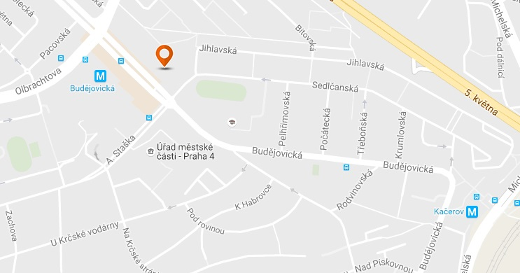
The Hotel ILF is located in a quiet part of Prague 4.
You can easily get to the HiLASE Center using public transport. The nearest Metro station "Budějovická" is located 100 meters from the hotel. At Budějovická take a metro and go to the next station “Kačerov”. At Kačerov metro station there are the buses number 331 and 333 which are going to the village Dolní Břežany. In Dolní Břežany you get off at station “Obecní úřad”.
Please find more details about timetable at this website: http://jizdnirady.idnes.cz/praha/spojeni/


